**The request from Larry Aaron has been working on:**

From Oct 12, 2022 email:

… estimate eqn 75 using GLS to obtain an estimate of sigma^2 and use eq 77 to estimate sigma^_{mu}. (You would also need to use 76 and the estimates of B_0 and h(t) to recover the region-specific fixed effects.)

**Equation 75 estimation**

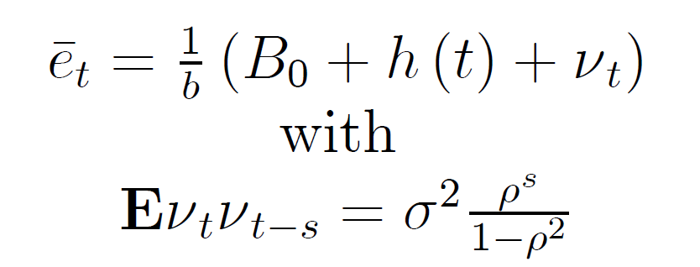

I am estimating eqn 75 using a FGLS procedure developed by Mackinnon & Beach (1978) (MB for short), based on Cochrane–Orcutt (CO) and Prais-Winsten (PW) and referenced by Greene. This is the “the most common choice” as stated by Greene and the MB paper is very easy to follow. It is more efficient than CO because the utilizes first observation and imposes the a priori assumption that |ρ|<1, which MB show can be important in small samples. This is an iterative procedure to estimate ρ using the aggregate global emissions timeseries. "The technique proceeds by alternately maximizing [the LL] with respect to β, ρ held fixed, and then maximizing [the LL] with respect to ρ, β held fixed." It’s a pretty straightforward procedure after having programmed the CO and PW estimators.

I have also estimated the CO and PW estimators, and ρ from all are very close in value and well within each other’s 95% confidence intervals. I also check the MB results against a stata package that employs the MB procedure. My results match down to rounding error.

The results are estimates of ρ, B₀/b, β₁/b, β₂/b, σ²θ, and their confidence intervals, where , β₁, β₂ are the parameters on the linear and quadratic time trends in h(t). I also included the estimates for σ²μ and b₀₁-B₀ in the table, which I explain below.

|  |  |  |  |  |
| --- | --- | --- | --- | --- |
|  | **Point Est** | **SE** | **CI Lower** | **CI Upper** |
| ρ | 0.913 | 0.046 | 0.807 | 1.018 |
| B₀ | 945.220 | 226.364 | 491.935 | 1,398.505 |
| β₁ | 93.482 | 15.983 | 61.476 | 125.488 |
| β₂ | 0.039 | 0.249 | -0.460 | 0.537 |
| σ²θ | 8,279.855 | 1,513.261 | 5,249.602 | 11,310.108 |
| σ²v | 49,598.955 |  |  |  |
| σ²μ/n | 164,416.491 |  |  |  |
| b₀₁-B₀ | 241.349 |  |  |  |
| b₀₂-B₀ | -1,077.981 |  |  |  |
| b₀₃-B₀ | 473.579 |  |  |  |
| b₀₄-B₀ | 363.052 |  |  |  |

* For the b₀₁-B₀ parameters: "USA"=>1, "EU"=>2, "BRIC"=>3, "Other"=>4

The confidence intervals are actually quite wide (especially for ρ), and incorporate previous estimates for ρ.

**Equation 77 estimation**

Equations (76) and (77) are straightforward to calculate from the grouped data. The b₀₁-B₀ parameters can be calculated without dropping any of the regions. But to calculate equation (77), I dropped the 4th region (“Other”) before generating the y, s, and Ω matrices.

**σ²θ vs σ²μ**

Here, σ²θ is σ² = σ²α + σ²μ/n. Thus, if σ²α >= 0, we should see σ²μ/n <= σ²θ. But that is not the case. However, we have no estimate of the standard error of σ²μ/n. If the SE for σ²μ/n are as large as the SE for σ²θ in percentage terms,

%SE for σ²θ = 1,513.261*100 / 8,279.855 = 18.276%

then the SE for σ²μ/n would be

SE for σ²μ/n = 18.276% * 164,416.491 = 30,049.452

which would mean 95% confidence intervals of about

CI for σ²μ/n = 164,416.491 +/- 2 * 30,049.452 = [134,367.039, 194,465.943]

which still has a lower bound an order of magnitude greater than the σ²θ confidence interval upper bound.

**Possible GMM proposal**

We have already noted that these two estimation procedures are disjoint. I know we have already tried the ML joint procedure. What I also think could be interesting to try is a GMM procedure that combines the moment conditions for all the estimated parameters. If you are able to write the moment conditions down (it seems that the region fixed effects and σ²μ/n moment conditions are already written down in equations (76) and (77)), then I think I could write the GMM procedure.

**Data Details**

* All data was imported in units of Mt CO2, as Andy converted them.
* ts_allYears_nation.1751_2014.csv was used for the ρ, B₀/b, β₁/b, β₂/b, σ²θ estimation.
* grouped_allYears_nation.1751_2014.csv was used for the σ²μ
* I believe all “linear” parameters (except ρ?) estimates also contain the 1/b term, while all the variance terms contain the 1/b² term

**References**

[MB] James Mackinnon and Charles Beach, “A Maximum Likelihood Procedure for Regression With Autocorrelated Errors,” Econometrica 46 (January 1, 1978): 51–58, https://doi.org/10.2307/1913644.